First of all , after you run the code, it will ask to enter a choice.

For that it is mandatory to press 1 and add a movie.

Because it is necessary to check whether the new movies that are released recently are present in the list or not. And later you can continue by entering your own options. One can only book a movie only after adding a movie of their preffered choice.

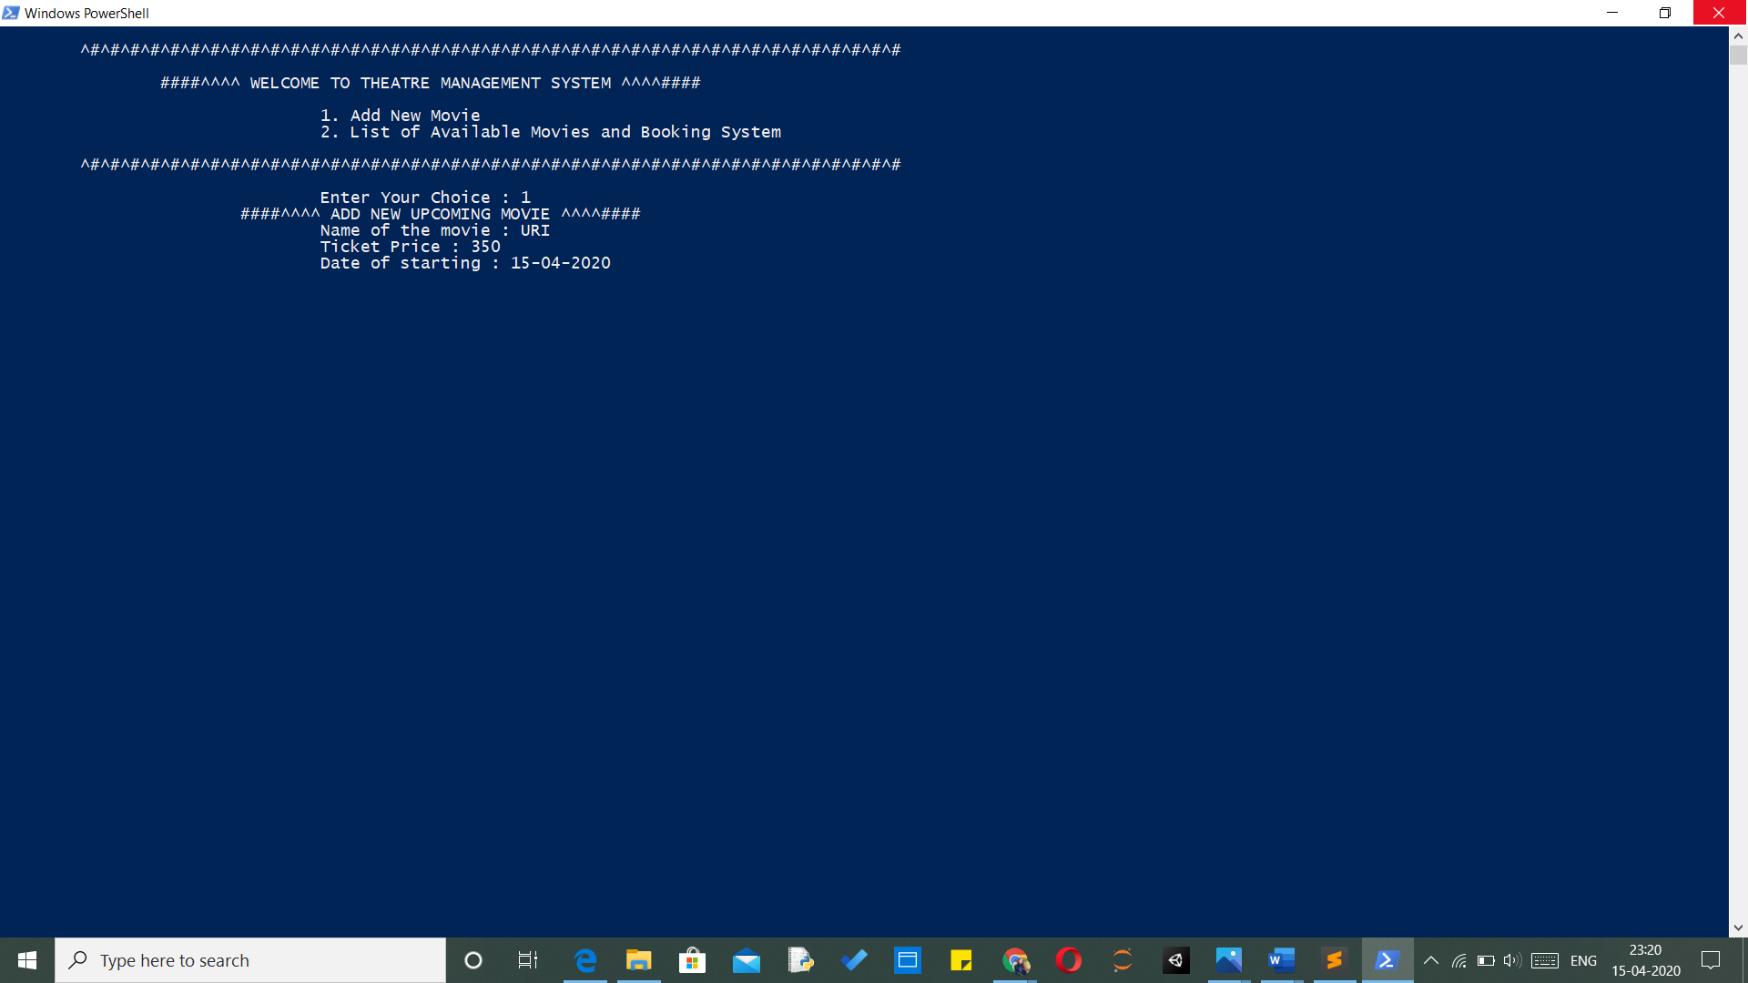

In the above image, first we have chosen1 option and added the movie and required preferences

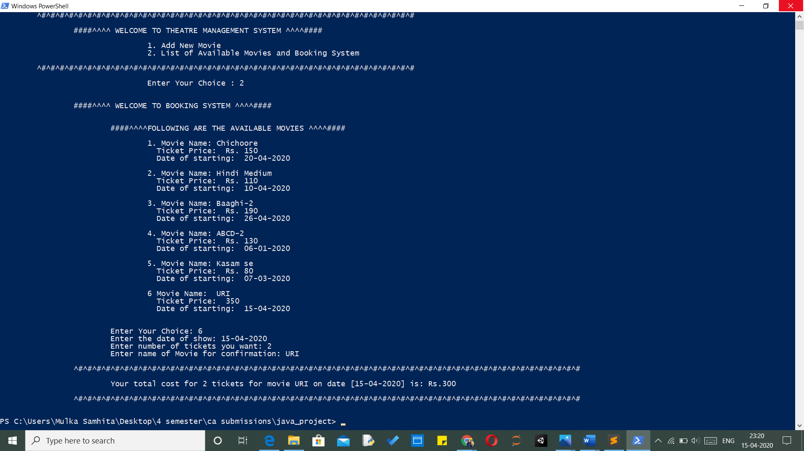

In this pic 2, we have opted 2 as choice for booking. And we can see that there is URI movie is present that we added as the movie.

After filling the credentials, we get the movie ticket conformation